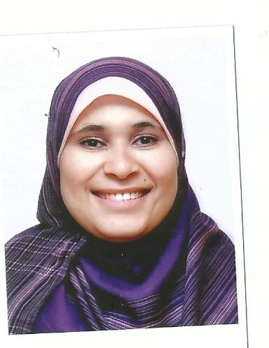
Reem Abed EL Moneim Taha Haggag
Mathematics Teacher
Alsulymania - Riyadh - KSA
Cell: +201009927008
rhaggag76 @gmail.com.

Mathematics Teacher
G3 ,G4 and G5 and G6 – American International Cirruculum

Aspiring for career enriching assignments as Snr Math Teacher for International Circulums in an International Schools.
Location Preference: KSA /Egypt

PROFESSIONAL PROFILE

Synopsis: Accomplished professional offering 18 years of experience in teaching Mathematics for elementary stage & Primary stages in National and International circulums in Languages & International Schools in Egypt and Suadi Arabia

PROFESSIONAL EXPERIENCE

Genuises of knowledge International school – Riyadh – Saudi Arabia
Math Teacher for – elementary Stage (2014 –May2017)

Key Profile:
- Math Teacher for G3,G4 ,G5 and G6 students.
- I have a sound of excellent experience in dealing with students in both class base approach and workshop approach.
- I am mastering the use of Educations aids in communicating with my students in clssrooms , helping them in discovering their creativity and devlope their skills .
- Creative in developing educational assignments , activities and projects
- Having very good communication skills in addition to classroom control skills .

Memphis International School– Cairo – Egypt
Math Teacher – Grades & Primary Stages ( August 2011 – June 2014)

Key Profile:
- Math Teacher for G3,G4 , G5 and G6 in the Elementary stage in an American Section.
- Math Teacher for 3rd ,4th , 5th and 6th primary classes in National Section

Cairo ModernInternational Schools for Girls – Cairo - Egypt
Math Teacher – Elementary Stage ( August 2008 – July 2011)

Key Profile:
- Math Teacher for G2, G3 , G4 ,G5 and G6 CMIS.
Manarat AL Farouk Eslamic Language schools – Cairo - Egypt
Math Teacher – Primary Stage (August 2007 – July 2008)

Key Profile:
- Math Teacher for 3rd and 4th primary classes.

Dr. NermineIsmaeil Language Schools – Cairo - Egypt
Math Teacher – Primary Stage (August 2004 – July 2007)

Key Profile:
- Math Teacher for 2nd, 3rd and 4th primary classes.

The Egyptian Language School – Cairo - Egypt
Math Teacher – Primary Stage (September 2001 – August 2004)

Key Profile:
- Math Teacher for 2nd primary classes.

KENANA Language School – Cairo - Egypt
Math Teacher – Primary Stage (September 2002 – July 2002)

Key Profile:
- Math Teacher for 2nd and 3rd primary classes.

Menese Language School – Cairo - Egypt
Math Teacher – Primary Stage (September 2000 – July 2001)

Key Profile:
- Math Teacher for primary STAGE 2nd and 3rd primary .

ACADEMIC Qualification

B.Sc in Commerce – Faculty of commerce - Ain Shams University –
Cairo – Egypt on 1999

Graduated in Ramses College for girls (Ex. American College for girls )- Cairo –Egypt from 1981 till 1995.

Other HIEHER EDUCATION / Professional training/ certificate/Skills

- Computer Programming on july 1997 (very good ) - Egypt
- Windows 95 at Sadat Academy , sept. and oct.1998 (Very good)-Egypt
- Excel 2000, at Information System Institute .August 2000. (Good) - Egypt
- Studying Information Computer Driving Licsence Course(ICDL) from August 2009 till September 2010.
- Courses in Human Development to be A cerified Professional Trainner in the Canadian Center in Egypt , Dr.Ibrahim el fiky.
- Education assessment skills – 2015 – GamaLearn – Riyadh – Saudi Arabia.
- Leadership skills in Education – 2016 - Al-Amal International Training Center ,
Cairo – Egypt
- Othere online courses in self development and soft skills – 2014 -2016.

- A certified MATH teacher in teaching the American CURRICULUM , THROUGH THE GLOBAL Conference offered by AdvancED AND IT WAS HELD IN RIYADH Saudi Arabia Feb 18-2017.

Skills

Skill Level Years Practiced Last used
Communication skills Expert More than 10 years 1 month or less
Report Writing Expert More than 10 years 1 month or less
Microsoft office applications Expert More than 10 years 1 month or less
Educational activities design Expert 5 Years 1 month or less

PERSONAL PARTICULARS

- Date of Birth: 06/07/1976
- Languages Skills :
  - Arabic mother tongue
  - English fluent Very Good ( Spoken and Written)
  - French Good (Spoken and Wrtten)
- Egyptian Nationality , Resident of Riyadh, Saudi Arabia and Egypt .
- Marital Status : Single

